JAVA TIC-TAC-TOE LAB REPORT

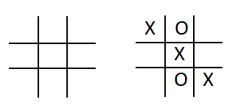
Name and Student ID: Jibran Akhter - 1073973
Date project completed: 3/17/2024
Platform (Mac, PC, Linux, etc.): Windows 11 PC
Development system (onlineGDB, NetBeans, Eclipse): onlineGDB

OBJECTIVES
Create a program that uses a two-dimensional array
Validate user inputs
Identify when a game is won or tied
Subdivide the code into subroutines and functions

PROJECT DESCRIPTION
Create a program using a two dimension array and methods that lets two players play the tic-tac-toe game. The program is to read a number from 1 to 9 from the keyboard alternating between the X and the O. Ask which square the X player wants, and then ask which square the O player wants. Continue until the game is won by either player, or all the squares have been filled. (Called a Cat's Game or a Tie Game)

A Java method must be used to display the tic-tac-toe game board, and a method must be used that determines if the game has been won. You can create the program on your own, or start with the sample code provided. Sample code is located at http://program-info.net/Java/downloads/JavaTicTacToe/JavaTicTacToe.java

EXTRA CREDIT
(up to 3 points) The extra credit upgrade MUST be submitted before the lab report is first graded.
Modify the displayTicTacToe( ) method using the | and – characters to draw lines for the tic-tac-toe display.

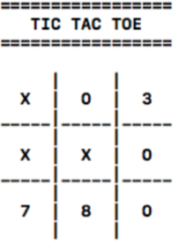
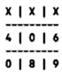
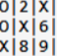
3 points
extra credit
2 points
extra credit
1 point
extra credit

DISCUSSION
What did you do to develop the program? ("Followed the Directions" is not a complete description)

In developing the Tic Tac Toe program, I used the professor's initial code snippet provided for the project. Leveraging the structure and logic laid out by our instructor, I began by setting up the game grid using a two-dimensional array in Java. Following the professor's lead, I ensured that user inputs were properly validated, allowing only selections within the range of 1 to 9 and confirming that the chosen square was available for marking. Building upon the foundation laid out by our professor, I further subdivided the code into manageable functions, each with a specific responsibility. These functions included displaying the game board and checking for win conditions, contributing to the clarity and maintainability of the codebase. I decided to add some creativity by enhancing the visual representation of the game. Drawing upon the professor's initial logic, I modified the display function to incorporate stylish lines using | and – characters.

What problems did you have and how did you overcome the problems?

One issue arose when validating user inputs. Initially, I struggled to ensure that inputs fell within the range of 1 to 9 and that selected squares weren't already occupied. To tackle this, I implemented robust checks within the code, prompting users to re-enter their choices if they didn't meet the criteria. Another hurdle was subdividing the code into functions. At first, I found it a bit daunting to determine the appropriate boundaries for each function and how they would interact with one another. To overcome this, I took a step back and carefully planned out the flow of the program. Lastly for the extra credit drawing lines using | and – characters. While it added a nice touch to the game's aesthetics, I had to ensure that it didn't compromise the functionality of the program. By experimenting with different approaches. I even had the opportunity to be efficient enough by entering the program in such a way that bot x and o would enter the values at the same time however I found doing it to be difficult, so I stuck with what I had.

FOUR SCREENSHOTS
Capture only the portion of the screen that shows the calculator or program output. Do not capture the entire screen even though it may also contain the program output. If I need to zoom in on a screenshot, sometimes the image resolution is so poor that I am not able to read it. If this happens, I will ask that you resubmit your lab report. Refer to these instructions capturing screenshots and pasting them to the lab report.

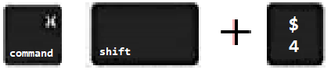
For the Mac
- hold down command + shift keys and press the 4 key
to get a screenshot of a selected area of the screen

- Use the mouse or touchpad to select the desired area of the screen you want to save
- use command+V to paste into the lab report

For Windows

- use Microsoft's Snipping Tool by holding down the
Windows and Shift keys and tapping the ‘S’ key

- Use the mouse or keypad to select the part of the screen you want to save
- use Ctrl+V to into the lab report

Paste four screenshots here

(Scroll Down)

Screenshot #1 – a win going across

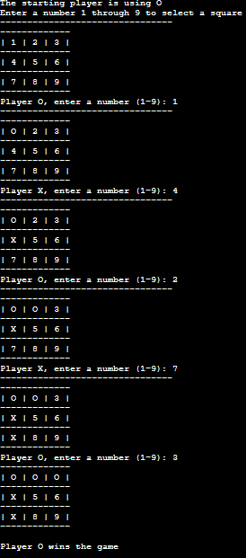

Screenshot #2 – a win going down

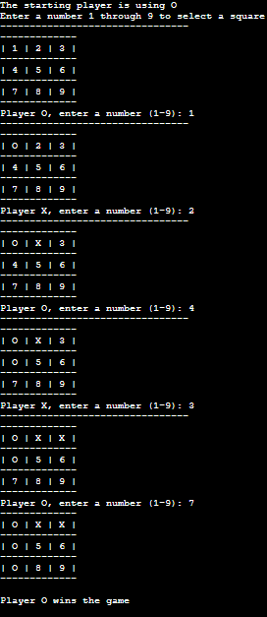

Screenshot #3 – a win going at a diagonal

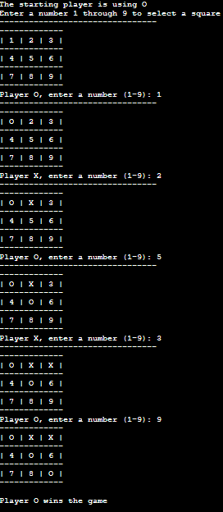

Screenshot #4 – a tie game
